A

Project Report

On

**“CRUD(iNOTES)”**

Submitted in partial fulfillment of

the requirements for the 5th Semester Sessional Examination of

BACHELOR OF TECHNOLOGY

IN

**COMPUTER SCIENCE & ENGINEERING**

By

**SHAHID AKHTAR**

**Registration No. 1801210557**



**DEPARTMENT OF COMPUTER SCIENCE & ENGINEERING**

**GIET MAIN CAMPUS AUTONOMOUS**

**GUNUPUR – 765022**

**2020 - 21**

**GIET MAIN CAMPUS AUTONOMOUS,**

**GUNUPUR-765022, Dist: Rayagada (Orissa), India**

**(Approved by AICTE and Govt, of Orissa)**

**Ph: 06857 – 250172(Office), 251156(Principal), 250232(Fax),**

**E-mail:** [**gandhi_giet@yahoo.com**](mailto:gandhi_giet@yahoo.com) **visit us at WWW.giet.org**

**Department of Computer Science & Engineering**



**CERTIFICATE**

This is to certify that the project work entitled “**CRUD(iNOTES)**” is done by **SHAHID AKHTAR-, Regd. No.1801210557 -**in partial fulfillment of the requirements for the 5th Semester Sessional Examination of Bachelor of Technology in Computer Science and Engineering during the academic year 2020-21. This work is submitted to the department as a part of evaluation of 5th Semester Project.

Name

Class Teacher Prof. (Dr) .Sanjay Kumar Kuanar

Rasmita Panigrahi HoD, CSE

**ACKNOWLEDGEMENT**

If words are considered as a symbol of approval and token of appreciation then let the words play the heralding role expressing my gratitude.

The satisfaction that accompanies that the successful completion of any task would be incomplete without the mention of people whose ceaseless cooperation made it possible, whose constant guidance and encouragement crown all efforts with success. We are grateful to our project guide Ms.Rasmita Pangrahi for the guidance, inspiration and constructive suggestions that helpful us in the preparation of this project. We also thank our colleagues who have helped in successful completion of the project.

Shahid Akhtar

1. **Introduction:-**

* CRUD is an acronym that comes from the world of databases. Each letter stands for one type of action that a user can perform on a set of data: *C*reate, *R*ead, *U*pdate, and *D*elete. In relational databases, the four activities match the SQL commands INSERT, SELECT, UPDATE and DELETE. This “iNotes” application have help to take only important notes in relevant way. No user need to spend more time to take notes. It’s very easy way to take notes. Any kind of user can upload they their notes as what time they want. Its take very less time to open the”iNotes apps”.Due to the very easy design of this apps, school students can also use this apps to take their notes in efficient manner.

**Table of contents**

|  |  |  |
| --- | --- | --- |
| **Sr.No** | **Topic** | **Page Number** |
| 1. | **Introduction** | 01-06 |
|  | **1.1 Work Process** |  |
|  | **1.2 Scope & Purpose** |  |
|  | **1.3 Existing System** |  |
|  | **1.4 Proposed System** |  |
|  | **1.5 Project Analysis** |  |
| 2. | **System Analysis** | 07 |
|  | **2.1 Hardware requirements** |  |
|  | **2.2 Software requirements** |  |
| 3. | **System Design & Specifications** | 08-09 |
|  | **3.1 DFD (data flow diagram)** |  |
|  | 3.2 **UML(use case diagram)** |  |
| 4. | **Screenshot and result** | 10 |
| 5. | **Coding:- source code** | 11-17 |
| 6. | **Conclusion & Limitations** | 18 |
| 7. | Reference and Bibliography | 18 |
|  |  |  |
|  |  |  |
|  |  |  |
|  |  |  |
|  |  |  |
|  |  |  |
|  |  |  |
|  |  |  |
|  |  |  |
|  |  |  |
|  |  |  |
|  |  |  |
|  |  |  |

**1.1Work Process:-**

* In this project “iNotes” every user have their own username and password to access this Apps and can keep their notes personally. He/she can keep their notes with Title name and description so that user can easily recognize their notes he/she uploaded.
* This is very easy to identify their notes repositories in home screen itself.
* The user can easily search their notes in searching bar and filter too.

**1.2 Scope & Purpose:-**

* All users can upload and can share notes with other users.
* The users can add the notes in any format as they like.
* This is very fast and relevant way to store the notes.
* The users didn’t need anyusers permission to add notes in iNotes apps.
* The users can also keep some important link and study material.

**1.3 Existing System:-**

* As it is developed for user-friendly so any sort of users can add their notes from any educational platform. They needn’t need to go through anyother online offline software. This iNotes apps help to take key point of important notes.

**1.4 Proposed System:-**

* The main motto of this project is to user can add or upload nots easily and very quick than other software.
* User can modify their notes in very easy manner comparatively than other software.
* Notes repositories are available in the form of table manner so it is easy to identify your notes without wasting your time.
* Users can login from any location and upload notes and can share too.

**1.5 Project Analysis:-**

* This application has been divided in to only one module

User Module

1. System Analysis:-

**2.1 Hardware requirements:-**

* In hardware requirement we require all those components which will provide us the platform for the development of the project. The minimum hardware required for the development of this project is as follows-
  + Laptop / Pc with keyboard and mouse
  + RAM- minimum 128 MB
  + Hard disk- minimum 5 GB
  + processor- Intel CORE i5
  + CD drive
* These all are the minimum hardware requirement required for our project. We want to make our project to be used in any. Type of computer therefore we have taken minimum configuration to a large extent.128MB ram is used so that we can execute our project in a least possible RAM.5GB hard disk is used because project takes less space to be executed or stored. Therefore minimum hard disk is used. Others enhancements are according to the needs.

**2.2 Software requirements:-**

* Software’s can be defined as programs which run on our computer. It act as petrol in the vehicle. It provides the relationship between the human and a computer. It is very important to run software to function the computer. Various software’s are needed in this project for its development which are as follows-
  + Operating System- windows10
  + Visual studio code
  + Google chrome
  + MySQL database
  + Xampp Control panel (for local server)
* We will be using visual studio code basic as our front hand because it is easier to use and provides features to the users which is used for the development of the project.

1. **System Design & Specifications :-**

**3.1 DFD;-**

## 

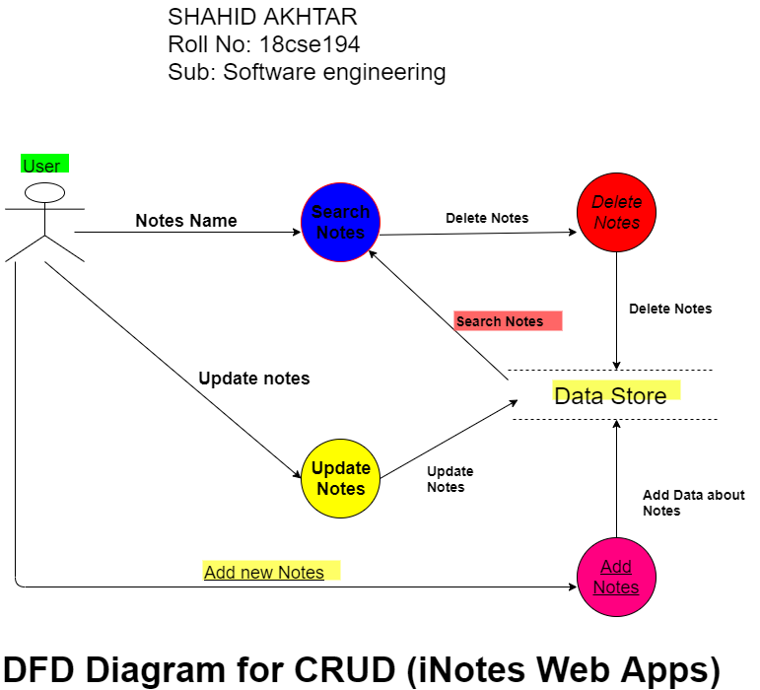

3.2 **UML:-**

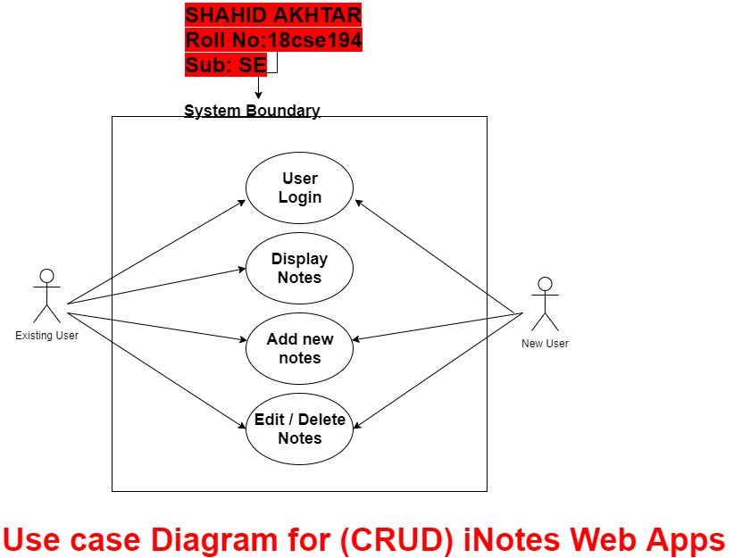

1. **Screenshot and result:-**

**5 .Coding:- source code:**

<?php

$insert =false;

$update=false;

$delete=false;

// connect to the database

$servername = "localhost";

$username = "root";

$password = "";

$database ="notes";

// Create a connection

$conn = mysqli_connect($servername, $username, $password,$database);

// Die if connection was not successful

if (!$conn){

die("Sorry we failed to connect: ". mysqli_connect_error());

}

if(isset($_GET['delete'])){

$sno = $_GET['delete'];

$delete = true;

$sql = "DELETE FROM `notes` WHERE `sno` = $sno";

$result = mysqli_query($conn, $sql);

}

if($_SERVER['REQUEST_METHOD'] == 'POST'){

if(isset($_POST['snoEdit'])){

$sno= $_POST['snoEdit'];

$title= $_POST['titleEdit'];

$description= $_POST['descriptionEdit'];

$sql ="UPDATE `notes` SET `title` = '$title', `description` = '$description' WHERE `notes`.`sno` = $sno;";

$result = mysqli_query($conn, $sql);

if($result){

$update=true;

}

else{

echo "we could not update record data sucesssfully";

}

}

// updtae the record

else {

$title= $_POST['title'];

$description= $_POST['description'];

$sql ="INSERT INTO `notes` (`sno`, `title`, `description`, `tstamp`) VALUES (NULL, '$title', '$description', current_timestamp())";

$result = mysqli_query($conn, $sql);

if($result){

//echo "the record is updated successfully";

$insert =true;

}

else{

echo "The data is not inserted successfully because of this error ---> ". mysqli_error($conn);

}

}

}

?>

<!doctype html>

<html lang="en">

<head>

<!-- Required meta tags -->

<meta charset="utf-8">

<meta name="viewport" content="width=device-width, initial-scale=1, shrink-to-fit=no">

<!-- Bootstrap CSS -->

<link rel="stylesheet" href="https://cdn.jsdelivr.net/npm/bootstrap@4.5.3/dist/css/bootstrap.min.css" integrity="sha384-TX8t27EcRE3e/ihU7zmQxVncDAy5uIKz4rEkgIXeMed4M0jlfIDPvg6uqKI2xXr2" crossorigin="anonymous">

<link rel="stylesheet" href="//cdn.datatables.net/1.10.22/css/jquery.dataTables.min.css">

<title>iNotes - notes taking made easy</title>

<style>

body{

color: rgb(91, 13, 236);

font-family: verdana,Arial,Geneva,Arial black;

font-weight: normal;

background-color: #ebf1ec;

}

</style>

</head>

<body>

<!-- Button trigger modal -->

<!--<button type="button" class="btn btn-primary" data-toggle="modal" data-target="#editModal">

Edit modal

</button>-->

<!-- edit Modal -->

<div class="modal fade" id="editModal" tabindex="-1" aria-labelledby="editModalLabel" aria-hidden="true">

<div class="modal-dialog">

<div class="modal-content">

<div class="modal-header">

<h5 class="modal-title" id="editModalLabel">Edit the Note</h5>

<button type="button" class="close" data-dismiss="modal" aria-label="Close">

<span aria-hidden="true">&times;</span>

</button>

</div>

<form action="/crud/index.php" method="POST">

<div class="modal-body">

<input type= "hidden" name="snoEdit" id="snoEdit">

<div class="form-group">

<label for="exampleInputEmail1">Note Title</label>

<input type="text" class="form-control" id="titleEdit" name="titleEdit" aria-describedby="emailHelp">

</div>

<div class="form-group">

<label for="desc">Note Description</label>

<textarea class="form-control" id="descriptionEdit" name="descriptionEdit" rows="3"></textarea>

</div>

</div>

<div class="modal-footer d-block mr-auto">

<button type="button" class="btn btn-secondary" data-dismiss="modal">Close</button>

<button type="submit" class="btn btn-primary">Save changes</button>

</div>

</form>

</div>

</div>

</div>

<nav class="navbar navbar-expand-lg navbar-dark bg-dark">

<a class="navbar-brand" href="#"><img src="company profile.png" height="70px" alt=""></a>

<button class="navbar-toggler" type="button" data-toggle="collapse" data-target="#navbarSupportedContent" aria-controls="navbarSupportedContent" aria-expanded="false" aria-label="Toggle navigation">

<span class="navbar-toggler-icon"></span>

</button>

<div class="collapse navbar-collapse" id="navbarSupportedContent">

<ul class="navbar-nav mr-auto">

<li class="nav-item active">

<a class="nav-link" href="#">Home <span class="sr-only">(current)</span></a>

</li>

<li class="nav-item">

<a class="nav-link" href="#">About</a>

</li>

<li class="nav-item">

<a class="nav-link" href="#">contact us</a>

</li>

</ul>

<form class="form-inline my-2 my-lg-0">

<button class="btn btn-outline-success my-2 my-sm-0" type="submit"><a href="login.html">login</a></button>

</form>

</div>

</nav>

<?php

if($insert){

echo "<div class='alert alert-success alert-dismissible fade show' role='alert'>

<strong>sucess!</strong> Your Notes has been inserted sucessfully.

<button type='button' class='close' data-dismiss='alert' aria-label='Close'>

<span aria-hidden='true'>&times;</span>

</button>

</div>";

}

?>

<?php

if($update){

echo "<div class='alert alert-success alert-dismissible fade show' role='alert'>

<strong>sucess!</strong> Your Notes has been updated sucessfully.

<button type='button' class='close' data-dismiss='alert' aria-label='Close'>

<span aria-hidden='true'>&times;</span>

</button>

</div>";

}

?>

<?php

if($delete){

echo "<div class='alert alert-success alert-dismissible fade show' role='alert'>

<strong>sucess!</strong> Your Notes has been deleted sucessfully.

<button type='button' class='close' data-dismiss='alert' aria-label='Close'>

<span aria-hidden='true'>&times;</span>

</button>

</div>";

}

?>

<marquee direction="up" behavior="alternate" height="100">

<marquee behavior="alternate" scrollamount="15" style="font-family: book Antiqua; color:#f33f08;"><font size="6"> Wel Come to iNotes Apps</font></marquee>

</marquee>

<div class="container my-3">

<h2> Add a note to iNotes App</h2>

<form action="/crud/index.php" method="POST">

<div class="form-group">

<label for="exampleInputEmail1">Note Title</label>

<input type="text" class="form-control" id="title" name="title" aria-describedby="emailHelp">

</div>

<div class="form-group">

<label for="desc">Note Description</label>

<textarea class="form-control" id="description" name="description" rows="3"></textarea>

</div>

<button type="submit" class="btn btn-primary">Add Note</button>

</form>

</div>

<div class="container my-4">

<table class="table" id="myTable">

<thead>

<tr>

<th scope="col">S.No</th>

<th scope="col">Title</th>

<th scope="col">Description</th>

<th scope="col">Actions</th>

</tr>

</thead>

<tbody>

<?php

$sql = "SELECT * FROM `notes`";

$result = mysqli_query($conn, $sql);

$sno=0;

while($row = mysqli_fetch_assoc($result)){

$sno=$sno+1;

echo " <tr>

<th scope='row'>".$sno."</th>

<td>".$row['title']."</td>

<td>".$row['description']."</td>

<td> <button class='edit btn-sm btn-primary' id=".$row['sno'].">Edit</button>

<button class='delete btn-sm btn-primary' id=d".$row['sno'].">Delete</button>

</td>

</tr>";

}

?>

</tbody>

</table>

<hr></hr>

</div>

<!-- Optional JavaScript; choose one of the two! -->

<!-- Option 1: jQuery and Bootstrap Bundle (includes Popper) -->

<script src="https://code.jquery.com/jquery-3.5.1.slim.min.js" integrity="sha384-DfXdz2htPH0lsSSs5nCTpuj/zy4C+OGpamoFVy38MVBnE+IbbVYUew+OrCXaRkfj" crossorigin="anonymous"></script>

<script src="https://cdn.jsdelivr.net/npm/bootstrap@4.5.3/dist/js/bootstrap.bundle.min.js" integrity="sha384-ho+j7jyWK8fNQe+A12Hb8AhRq26LrZ/JpcUGGOn+Y7RsweNrtN/tE3MoK7ZeZDyx" crossorigin="anonymous"></script>

<!-- Option 2: jQuery, Popper.js, and Bootstrap JS

<script src="https://code.jquery.com/jquery-3.5.1.slim.min.js" integrity="sha384-DfXdz2htPH0lsSSs5nCTpuj/zy4C+OGpamoFVy38MVBnE+IbbVYUew+OrCXaRkfj" crossorigin="anonymous"></script>

<script src="https://cdn.jsdelivr.net/npm/popper.js@1.16.1/dist/umd/popper.min.js" integrity="sha384-9/reFTGAW83EW2RDu2S0VKaIzap3H66lZH81PoYlFhbGU+6BZp6G7niu735Sk7lN" crossorigin="anonymous"></script>

<script src="https://cdn.jsdelivr.net/npm/bootstrap@4.5.3/dist/js/bootstrap.min.js" integrity="sha384-w1Q4orYjBQndcko6MimVbzY0tgp4pWB4lZ7lr30WKz0vr/aWKhXdBNmNb5D92v7s" crossorigin="anonymous"></script>

-->

<script src="//cdn.datatables.net/1.10.22/js/jquery.dataTables.min.js"></script>

<script>

$(document).ready( function () {

$('#myTable').DataTable();

} );

</script>

<script>

edits = document.getElementsByClassName('edit');

Array.from(edits).forEach((element) => {

element.addEventListener("click", (e) => {

console.log("edit ");

tr = e.target.parentNode.parentNode;

title = tr.getElementsByTagName("td")[0].innerText;

description = tr.getElementsByTagName("td")[1].innerText;

console.log(title, description);

titleEdit.value = title;

descriptionEdit.value = description;

snoEdit.value = e.target.id;

console.log(e.target.id)

$('#editModal').modal('toggle');

})

})

deletes = document.getElementsByClassName('delete');

Array.from(deletes).forEach((element) => {

element.addEventListener("click", (e) => {

console.log("edit ");

sno = e.target.id.substr(1);

if (confirm("Are you sure you want to delete this note!")) {

console.log("yes");

window.location = `/crud/index.php?delete=${sno}`;

// TODO: Create a form and use post request to submit a form

}

else {

console.log("no");

}

})

})

</script>

</body>

</html>

**6.Conclusion & Limitations:-**

* This web application have almost all the features of CRUD and smart online/offline notes taking.
* The project has alto’s benefits. Managing the project is quite easy as per as storing the notes. It is easy to maintain notes and update as we required.
* As we know that the technology is increasing day by day so the hard copy note taking will be decreased, at that time it will helpful for those who will use this apps.
* Still there is some additional features is not added in the apps .As we are seeking of features, if its required we will add it as soon as possible.

One of the most important principles of Software Design is to keep the software simple yet effective. This has been the guiding force during the design phase of our software. And the Interface that we provide is no exception. Against the backdrop of this ideology we design a simple yet very effective interface. Hope every user have clear idea of using our “iNotes” Apps.

7. **Reference and Bibliography** :-

The helping materials are taken from online classes like youtuber Harry sir and Bootstrap website for html and css and other like php from laravell website.